How Much Do You Really Know About Emergency Water?

- Water can go bad. (Circle the best answer)
  - Water should be dumped out after six months and replaced with fresh.
  - Water does not go bad.
  - Water is only safe from the faucet or purchased from a store.
  - Water has a shelf life.

- It’s fine to store water in any type of plastic container I have at home. (Circle the best answer)
  - Rinsed-out Milk jugs are the best because they are food-grade.
  - Soda Bottles and Powerade/Gatorade bottles cannot be used for long-term water storage.
  - Store water in Non-BPA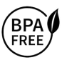polyethylene-based plastics, or plastics #1, #2, #4 and #5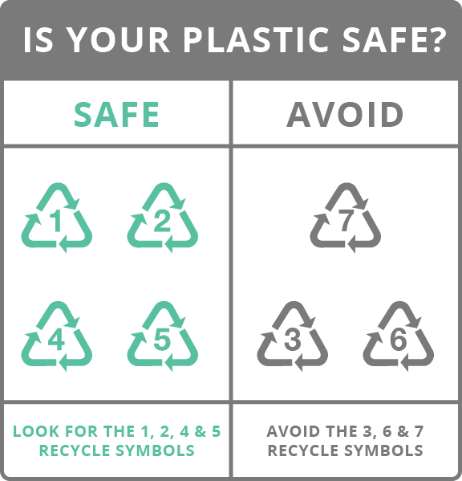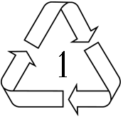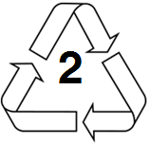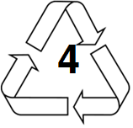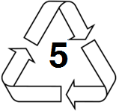

  - Nalgene bottles are made from compressed algae, hence the name.

- If I have a water barrel… (Circle the best answer)
  - I need other containers to store and transport water.
  - I’m set for every emergency I’ll encounter.
  - There’s plenty of water for the four of us and our pets for two weeks.
  - I’ll just roll it to where it’s needed.

- Storage Barrels are blue because… (Circle the best answer)
  - Blue means water.
  - Color has nothing to do with light exposure and biological growth (bacteria and algae).
  - Signifies that what is stored in the container is safe for human consumption.
  - It’s pretty.

- A gallon of water, per person, per day… (Circle the best answer)
  - Is all you need for adults.
  - Is the minimum for staying hydrated.
  - Should take care of all your water needs.
  - Sodas, coffee, tea, beer, wine, energy drinks, sport drinks, spirits are reasonable substitutes.

- If I have household bleach (sodium hypochlorite)… (Circle the best answer)
  - I don’t need a filter.
  - I don’t need a water purifier.
  - It will neutralize other chemicals.
  - It is not as effective as Chlorine Dioxide (Aqua Tabs) as a disinfectant that will kill 99.9% of all microorganisms in most circumstances against waterborne pathogenic agents such as viruses, bacteria and protozoa – including the cysts of Giardia and the oocysts of Cryptosporidium.

- To save space, I can stack my water barrels on top of each other. (Circle the best answer)
  - Most water barrels are built to stack end-on-end on each other.
  - Store your barrel directly on cement or on the floor in your garage for safety.
  - Stack barrels in a pyramid, using chocks and wedges.
  - Plastics can absorb flavors and odors from gasoline, liquids spilled on the floor, and chemicals used to create the concrete.

- Water Purifying Filters… (Circle the best answer)
  - Make sea water safe to drink.
  - All use reverse-osmosis to remove pollutants.
  - To be classified as a water purifier, must remove at least 99.9999% of pathogenic bacteria and reduce viruses by 99.99%.
  - Need 115v 60cycle power.
- Boiling water may be the cheapest and safest method of water purification. (Circle the best answer)
  - You can drink directly from a fast moving stream without boiling.
  - Removes all health hazards.
  - Eliminates organic and cellular substances and turbidity.
  - In this method, clean water should be brought to boil and left at rolling-boil for 1-3 minutes.

- Rinsing should be used to prepare water containers. (Circle the best answer)
  - Clean, used food containers are safe.
  - Containers and lids must be sanitized in disinfecting solution.
  - Running containers through the dishwasher is sufficient.
  - Hand washing with soap and a sponge will kill bacteria.

- I’ll be fine; I have a pool or a spa. (Circle the best answer)
  - Boiling will remove all harmful contaminants.
  - My dogs are safe drinking the water.
  - Purification removes 99.99% of organics, microorganisms, chlorine, metals and other chemicals.
  - Enough chlorine will protect from anything.

- Drinking water 1st for hydration, ____________ is the next priority for water. (Circle the best answer)
  - Making coffee.
  - Personal hygiene.
  - Washing clothes.
  - Flushing toilets.

Water Purification, Sanitization Solutions
Agent | Concentration | Clean Water | Turbid Water | Sanitizing | PPM
Iodine Tincture | 2% | 5 drops/qt | 10 drops/qt | 2 tsp / qt. | 12.5
Betadine | 10% | 4 drops/qt | 8 drops/qt | 1 tsp / gal. | 12.5
Bleach NaCIO | 5.25-6% (Halazone) | 2-4 drops/qt  (6 tablets /qt) | 4-8 drops/qt | 1 tbl / gal. clean water | 200
Chlorine Dioxide | 8.5mg (AquaTab) | 8.5mg/2 qt. | 8.5mg/ .8 qt. | 334mg/gal. clean | 200

Best Answers: 1:b, 2:c, 3:a, 4:c, 5:b, 6:d, 7:d, 8:c, 9:d, 10:b, 11:c, 12:b

